### **Triskele Sphere and Cube**

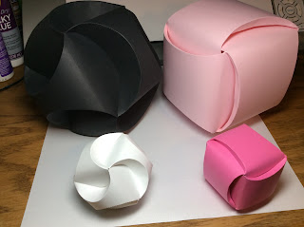

Triskele Sphere and Cube

I came across a triskele sphere at this website, <http://hattifant.com/triskele-paper-globes/>. I was intrigued by the sphere and I tweaked their design to make my sphere.

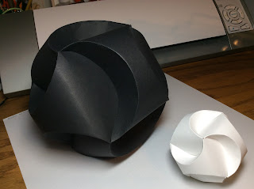

Two sizes of the Triskele Sphere

I then decided to modify the height of the arc by decreasing its size. In doing so, I discovered that I had to increase the width of the band to accommodate the difference. These modifications of the original triskele design resulted in a cube.

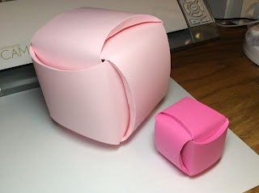

Triskele Cube

My patterns include two sizes for each of the triskele balls. There are three bands which interlock to form the structure. Here are the directions to construct the smaller one.  
  
<https://www.youtube.com/watch?v=u2-X2-GM9kc>To construct the larger one, glue two of the larger designs together to make one band. Repeat to make the other two bands. The construction is the same as the smaller one.